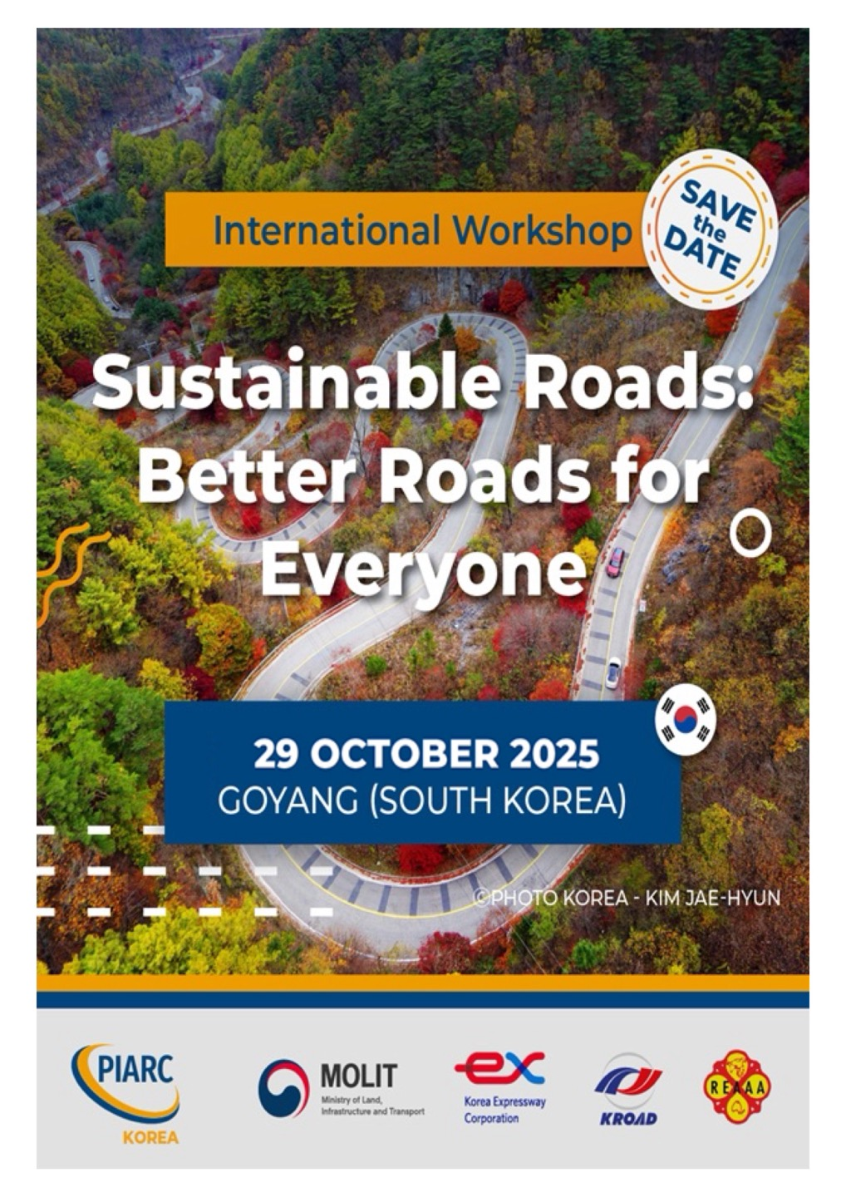

PIARC International Workshop

Sustainable Roads: Better Roads for Everyone
October 27–30, 2025 | KINTEX, Goyang, South Korea

PIARC and International Workshop

PIARC, the World Road Association, is a nonprofit organization founded in 1909. Over more than a century, PIARC has remained committed to its core mission: promoting international cooperation and the exchange of knowledge on issues related to roads and road transport. To support this mission, since 1999 PIARC has implemented a series of international workshops. These workshops aim to enhance the organization’s global presence, especially by addressing the needs of developing countries and economies in transition, and by ensuring the broad dissemination of technical insights and outcomes derived from its collective work.
PIARC delivers these workshops through its Technical Committees, which are composed of expert delegates appointed by member countries. These experts address a wide range of strategic topics defined in PIARC’s Strategic Plan, including road design, operations, maintenance, financing, and governance of responsible road agencies. The workshop serves as vital platforms for knowledge sharing and capacity building. They enable stakeholders—governments, researchers, private sector leaders, and civil society—to discuss challenges, showcase innovations, and co-create solutions for resilient, inclusive, and sustainable road systems. In today’s era of climate change, digital transformation, and social equity demands, PIARC’s international workshops are more critical than ever for facilitating global progress in the road transport sector.

Technical Committee 1.3. Finance and Procurement
Technical Committee 1.3 explores how finance and procurement mechanisms shape the social outcomes of road infrastructure projects. The committee emphasizes the need for transparent and equitable procurement practices across all project phases, from planning to operation. It investigates innovative financing models that support sustainable and inclusive road development, while aligning investment strategies with long-term public value. TC1.3 also studies the effectiveness of Public-Private Partnerships (PPPs) in improving efficiency, managing risks, and delivering socially beneficial outcomes. Special attention is given to integrating environmental, social, and governance (ESG) considerations into procurement frameworks to enhance accountability and resilience.
In addition, TC1.3 highlights the importance of early stakeholder engagement to ensure that community voices influence procurement decisions. It analyzes international case studies to identify and share best practices in ethical and inclusive procurement. The committee actively supports capacity building in developing and transition-economy countries, helping them strengthen financial governance and improve transparency in road project delivery. By promoting forward-looking financial and procurement strategies, TC1.3 seeks to position road infrastructure as a tool for achieving equitable mobility, climate goals, and sustainable economic growth.

Workshop Objectives

The World Road Association (PIARC), in collaboration with the Ministry of Land, Infrastructure and Transport of the Republic of Korea (MOLIT), Korea Expressway Corporation (KEC), Korea Road Association (KROAD), and the Road Engineering Association of Asia and Australasia (REAAA), is proud to announce the upcoming international workshop titled “Sustainable Roads: Better Roads for Everyone.” This workshop is designed to offer a dynamic platform for the exchange of knowledge and best practices in sustainable and inclusive road development. It will bring together a wide range of global stakeholders to share insights on how road infrastructure can be designed and implemented to better serve people, the environment, and future generations.
The primary objectives of the workshop are threefold. First, it aims to foster a collaborative space for sharing successful strategies and lessons learned in building sustainable road systems. Second, it seeks to explore how transparency, green transition, and inclusivity can be integrated into the planning, financing, and management of road projects. Lastly, the workshop intends to promote international dialogue among policymakers, industry leaders, engineers, researchers, and civil society on the most pressing challenges and future directions in road infrastructure, particularly in the context of climate change, equity, and innovation.

Participants and Audiences

This international workshop is open to government officials and public agency staff, road operators and concessionaires, consultants, engineers, urban planners, and procurement specialists, as well as representatives from financial institutions, international organizations, academia, and civil society. It welcomes anyone committed to advancing more sustainable and inclusive transportation systems.

Venue Information: KINTEX Exhibition Hall 2, Goyang City

KINTEX (Korea International Exhibition Center) is the largest and most advanced convention and exhibition venue in South Korea. Located in Goyang City, just northwest of Seoul, it offers excellent accessibility via subway, airport buses, and expressways. The venue features state-of-the-art facilities suitable for international conferences, exhibitions, and large-scale events. Surrounded by hotels, shopping centers, and cultural attractions, KINTEX provides a convenient and vibrant environment for participants. Goyang itself is a dynamic city known for its innovation, sustainability efforts, and international outlook.
- TC1.3 Meeting: KINTEX Exhibition Hall 2, Room 405 A
- International Workshop: KINTEX Exhibition Hall 2, Room 301

Dates: October 27-30, 2025

This international workshop is open to government officials and public agency staff, road operators and concessionaires, consultants, engineers, urban planners, and procurement specialists, as well as representatives from financial institutions, international organizations, academia, and civil society. It welcomes anyone committed to advancing more sustainable and inclusive transportation systems.
Date | Activity
October 27(Mon), All Day | TC1.3 Meeting (member only)
October 28(Tue), Half Day | TC1.3 Meeting (member ony)
October 29(Wed), All Day | International Workshop (Anyone)
October 30(Thur), All Day | TC1.3 Technical & Culture Visit (Member only)

Languages: English and Korean

Format

- TC1.3 Meeting: Hybrid (in-person & online participation)
- International Workshop: In-person (Only presenters can access online)

TC1.3 Meeting will be held in a hybrid format, allowing for both in-person and online participation.
In contrast, the International Workshop will be conducted exclusively in person. However, as an exception, online access and presentation will be permitted only for Session presenters. This measure is intended to minimize the risk of disruptions during the workshop due to potential communication failures.
Members of TC1.3 and other specialists will make the presentations, as well as panel discussions to open the dialogue to the public through a series of questions and answers.

Workshop Themes & Sessions

Session 1: Transparent Road Projects – Why Does It Matter?
- Ensuring transparency throughout all project phases: preparation, procurement, implementation, operation, and maintenance.
- Identifying barriers to disclosure and exploring practical alternatives.
- Sharing international standards and best practices for road project transparency.

Session 2: Green Transition of Roads – The Role of Funding and Procurement
- Innovative funding models for climate-friendly road infrastructure.
- Strategies to support low-carbon transition in new and existing road assets.
- Mobilizing finance and private sector investment toward carbon neutrality.

Session 3: Roads in the Era of Ecological and Technological Transition – Innovation through Inclusivity
- Navigating ecological and digital shifts in the early phases of road project planning.
- Integrating inclusive and equitable procurement policies and stakeholder engagement.
- Linking corporate diversity to improved climate performance and innovation in road infrastructure.

Contact and Registration
For inquiries, please contact:
- Ms. Belinda Mun : global@reaaakorea2025.org
- Official Website ‘REAAA Conference GOYANG 2025’ : https://reaaakorea2025.org/
PIARC TC International Workshop Registration (Oct. 29, Wed. All day) for free
- https://forms.gle/jisMsBe5MVvaA27u7

Preliminary Program Overview
Time | Oct. 27th  (Monday) | Oct. 28th  (Tuesday) | Oct. 29th  (Wednesday) | Oct. 30th  (Thursday)
09:00 | TC1.3Meeting | TC1.3Meeting | International Workshop  Registration | Technical Visit  (Han river Tunnel Construction Site)
09:50 |  |  | Opening Remarks
10:30 |  |  | Session 1.  Transparent Road Projects, Why Does It Matter?
12:00 | Luncheon | Luncheon |  | Luncheon
12:20 |  |  | Luncheon
13:00 | TC1.3Meeting | -
13:30 |  |  | Session 2.  Green Transition of Roads: The Role of Funding and Procurement | Culture Visit  (DMZ and Seoul)
14:00 |  | REAAA Opening  Ceremony
15:00 |  | -
15:20 |  |  | Coffee Break Time
15:50 |  |  | Session 3.  Roads in the Era of Ecological and Technological Transition
17:40
18:00 | Diner | Diner | Diner | Diner

Time | Title | Speaker
9:00-9:50 | Registration
10:00-10:30 | Opening session
5min | Opening | VIP Introduction
5min | Welcome Remarks | (PIARC) Seonha LEE, PIARC Korean NC Chair (Korea)
5min | Welcome Remarks | (PIARC) Emanuela STOCCHI, PIARC President (Italy)
5min | Thank You Remarks | (PIARC_TC 1.3) Rafael Aldrete, Chair/ Texas A&M Transportation Institute, Associate Director (Mexico)
10min | Photo | Group Photo
10:30-12:30 | Session 1 - Transparent Road Projects, Why Does It Matter? | Chair: (TBD)
20min | Overview and Policy Directions for Private Investment in Expressways | (MOLIT) Kise Lee, Ministry of Land, Infrastructure and Transport, Deputy Director (Korea)
20min | Advancing Transparency:  Early Findings and the Road Ahead | (PIARC_TC 1.3) Rafael Aldrete, Chair/ Texas A&M Transportation Institute, Associate Director (Mexico)
20min | Advancing Transparency in Road Projects | (ADB) Woo-Hyun Kwon, Asian Development Bank, Senior Transport Specialist (Korea)
20min | Maintenance Level Assessment and Monitoring System for Public-Private Partnership Highways in Korea | (KOTI) Hanbyul Jang, Korea Transport Institute, Chief Research Director (Korea)
40min | Panel Discussion | Panel Discussion (All Presenters)
12:30-13:30 | Lunch Break
13:30-15:20 | Session 2 - Green Transition of Roads: The Role of Funding and Procurement | Chair: Woo-Hyun Kwon, Asian Development Bank (ADB), Senior Transport Specialist (Korea)
20min | Filling the Gap, Enhancing the Connectivity | (KIND) Seunghwan Lee, Korea Overseas Infrastructure & Urban Development Corporation, Director (Korea)
20min | Update on PIARC study into improving sustainability outcomes for road projects through funding and procurement incentives | (PIARC_TC 1.3) Andy Warrington, Arcadis, Senior Technical Director (UK, on-line)
20min | Driving Progress: Korea's PPP Journey in Toll Road Infrastructure | (Macquarie) Jinwook Park, Macquarie Asset Management, Division Director (Korea)
20min | Green Finance for Sustainable Highway Projects in China | (PIARC_TC 1.3) Yanzhen Weng, China Academy of Transportation Sciences, Associate Researcher (China)
30min | Panel Discussion | Panel Discussion (All Presenters)
15:20-15:50 | Coffee Break
15:50-17:50 | Session 3: Roads in the Era of Ecological and Technological Transition: Innovation through Inclusivity | Chair: Rafael Aldrete, Chair of TC 1.3 / Texas A&M Transportation Institute, Associate Director (Mexico)
20min | Case Study on Canada: building resilient road corridors to improve inter-regional connectivity while advancing technology and climate goals | (PIARC_TC 1.3) Maria Shao, Transports Canada, Senior Program Policy Analyst (Canada)
20min | Expanding inclusive procurement and the application of environmental technologies in expressway sector | (PIARC_TC 1.3) Jae-Uoong Kim, Korea Expressway Corporation, Managing Director (Korea)
20min | Achieving Performance in Major Public Infrastructure Projects: The Case of Road Works in Senegal | (PIARC_TC 1.3) Mohamed Laye, AGEROUTE Senegal, Director of Road Asset Management and Maintenance (Senegal)
20min | A case study of the North East Link PPP package  in Australia | (GS E&C) Young Chang, GS Engineering & Construction, Vice President of Infra Overseas Business Departments (Korea)
30min | Panel Discussion | Panel Discussion (All Presenters)
10min | Closing
17:50 | End of Day

International Workshop Timetable

